Ansible Tower

Workflow templates and job templates for Service-Now Std change creation.

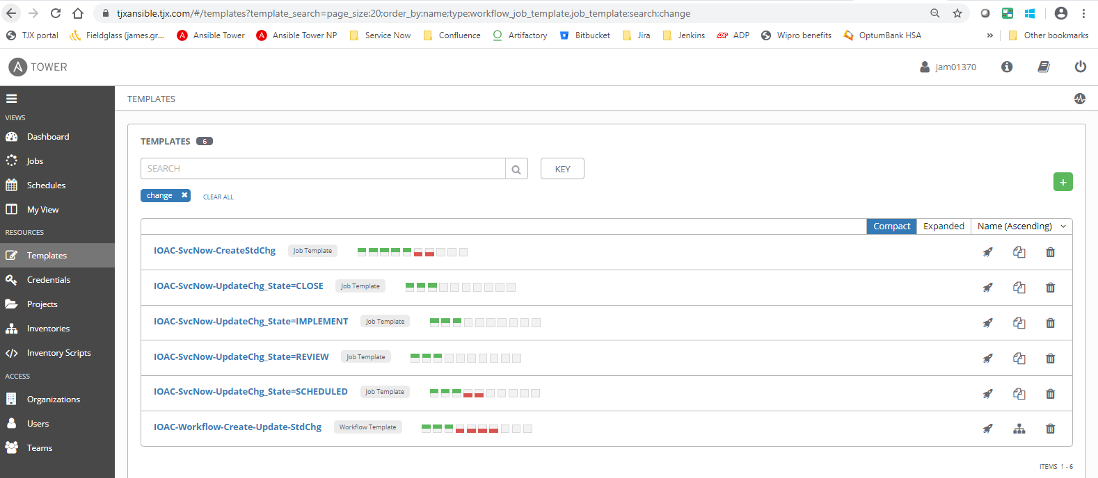

Workflow: IOAC-Workflow-Create-Update-StdChg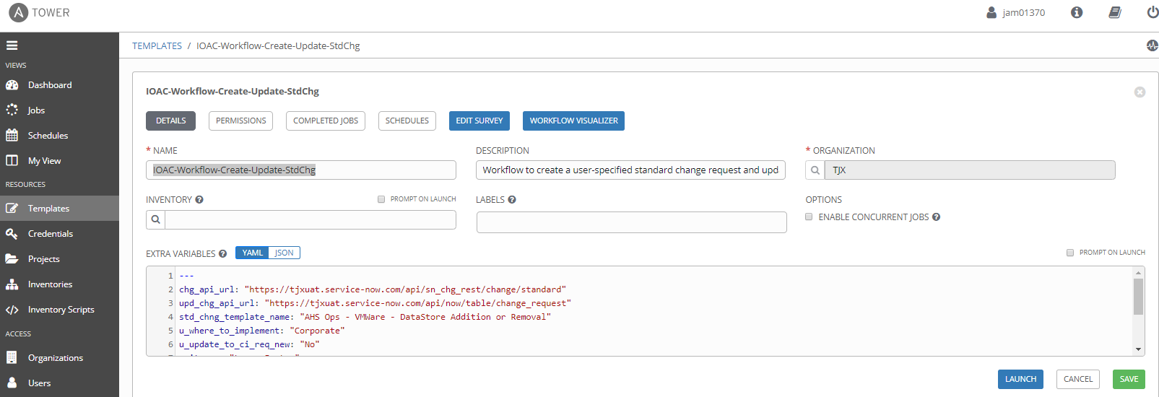

Project: IAOTEAM-3051-std-change-request-master

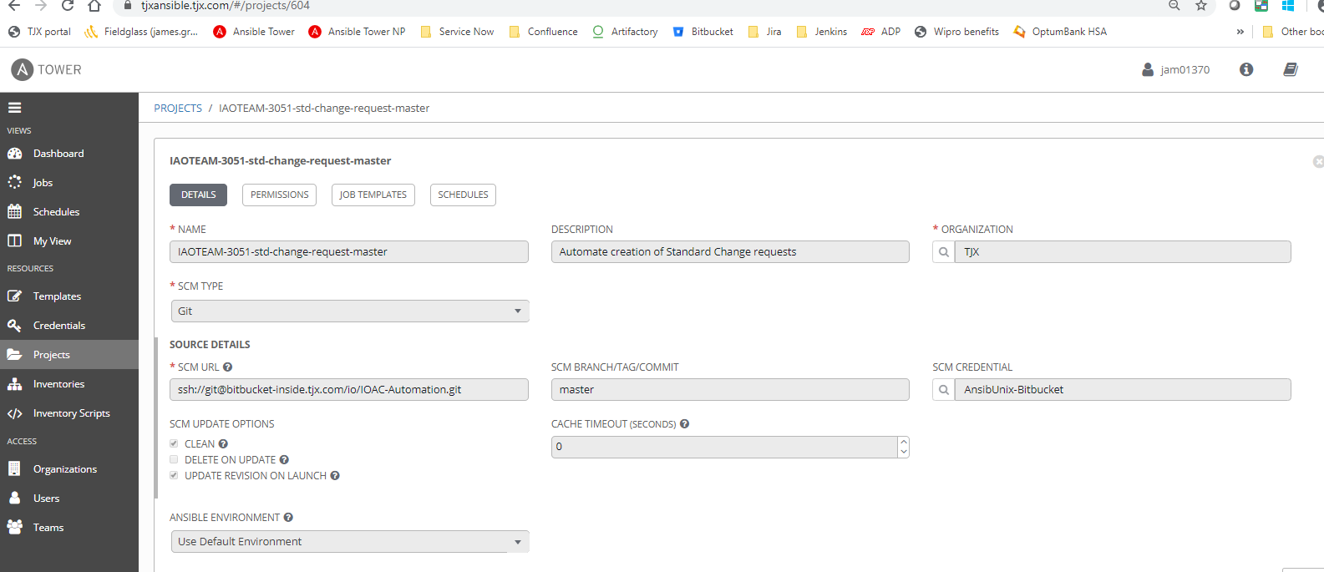

Job template: **IOAC-Upload-to-Artifactory**

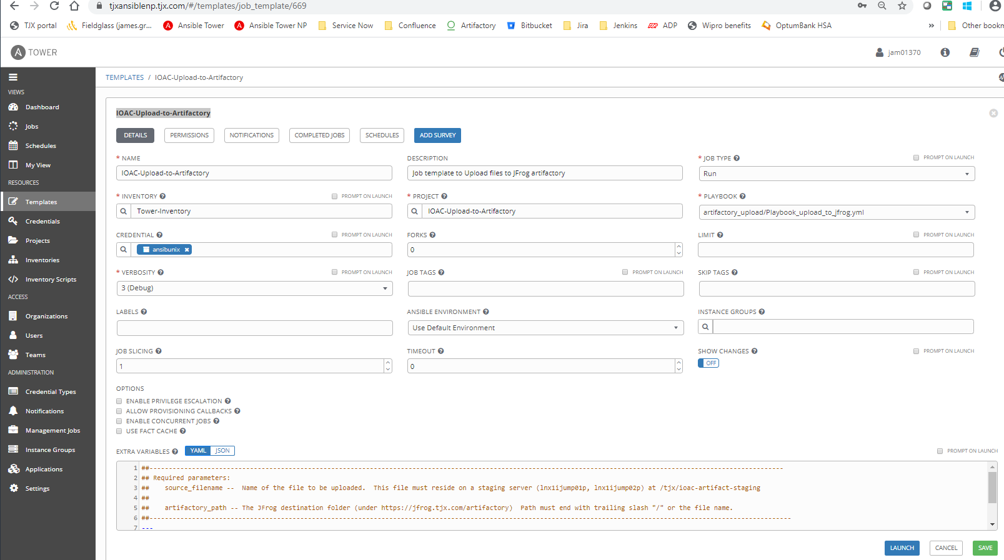

Generic inventory

